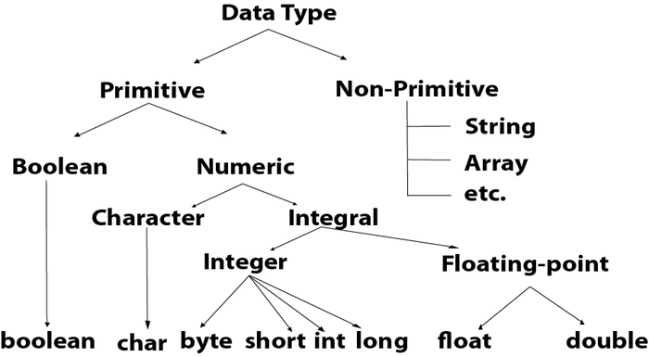

Boolean Data Type

The Boolean data type is used to store only two possible values: true and false. This data type is used for simple flags that track true/false conditions.

The Boolean data type specifies one bit of information, but its "size" can't be defined precisely.

**Example:**

1. Boolean one = **false**

Byte Data Type

The byte data type is an example of primitive data type. It isan 8-bit signed two's complement integer. Its value-range lies between -128 to 127 (inclusive). Its minimum value is -128 and maximum value is 127. Its default value is 0.

The byte data type is used to save memory in large arrays where the memory savings is most required. It saves space because a byte is 4 times smaller than an integer. It can also be used in place of "int" data type.

**Example:**

1. **byte** a = 10, **byte** b = -20

## Short Data Type

The short data type is a 16-bit signed two's complement integer. Its value-range lies between -32,768 to 32,767 (inclusive). Its minimum value is -32,768 and maximum value is 32,767. Its default value is 0.

The short data type can also be used to save memory just like byte data type. A short data type is 2 times smaller than an integer.

1. **short** s = 10000, **short** r = -5000

Int Data Type

The int data type is a 32-bit signed two's complement integer. Its value-range lies between - 2,147,483,648 (-2^31) to 2,147,483,647 (2^31 -1) (inclusive). Its minimum value is - 2,147,483,648and maximum value is 2,147,483,647. Its default value is 0.

The int data type is generally used as a default data type for integral values unless if there is no problem about memory.

**Example:**

1. **int** a = 100000, **int** b = -200000

Long Data Type

The long data type is a 64-bit two's complement integer. Its value-range lies between -9,223,372,036,854,775,808(-2^63) to 9,223,372,036,854,775,807(2^63 -1)(inclusive). Its minimum value is - 9,223,372,036,854,775,808and maximum value is 9,223,372,036,854,775,807. Its default value is 0. The long data type is used when you need a range of values more than those provided by int.

**Example:**

1. **long** a = 100000L, **long** b = -200000L

Float Data Type

The float data type is a single-precision 32-bit IEEE 754 floating point.Its value range is unlimited. It is recommended to use a float (instead of double) if you need to save memory in large arrays of floating point numbers. The float data type should never be used for precise values, such as currency. Its default value is 0.0F.

**Example:**

1. **float** f1 = 234.5f

Double Data Type

The double data type is a double-precision 64-bit IEEE 754 floating point. Its value range is unlimited. The double data type is generally used for decimal values just like float. The double data type also should never be used for precise values, such as currency. Its default value is 0.0d.

**Example:**

1. **double** d1 = 12.3

Char Data Type

The char data type is a single 16-bit Unicode character. Its value-range lies between '\u0000' (or 0) to '\uffff' (or 65,535 inclusive).The char data type is used to store characters.

**Example:**

1. **char** letterA = 'A'

# Unicode System

|  |
| --- |
| Unicode is a universal international standard character encoding that is capable of representing most of the world's written languages. |

### Why java uses Unicode System?

|  |
| --- |
| Before Unicode, there were many language standards: |
| * **ASCII** (American Standard Code for Information Interchange) for the United States. * **ISO 8859-1** for Western European Language. * **KOI-8** for Russian. * **GB18030 and BIG-5** for chinese, and so on. |

## Problem

|  |
| --- |
| **This caused two problems:**   1. A particular code value corresponds to different letters in the various language standards. 2. The encodings for languages with large character sets have variable length.Some common characters are encoded as single bytes, other require two or more byte. |

## Solution

|  |
| --- |
| To solve these problems, a new language standard was developed i.e. Unicode System. |
| In unicode, character holds 2 byte, so java also uses 2 byte for characters. |
| **lowest value:**\u0000 |
| **highest value:**\uFFFF |